Raymond Page
ENC 2135
Professor Brandi
February 2, 2017

How Game of Thrones Connects with its Audience
Game of Thrones has become one of HBOs most successful series. Although not everyone watches it, it is not uncommon to see numerous references to it in social media and other sources. The television series Game of Thrones has used a variety of genres with the intention of appealing to a wide base of people as an audience. Game of Thrones has created numerous posters for each of the seasons as a classic form of advertising as well as incorporating some unusual advertising strategies, such as, food trucks and an exceptionally imaginative use of the New York Times.
The HBO series Game of Thrones started their advertising campaign incredibly strong by using the image of the Iron Throne with Ned Stark sitting on it. The picture is absolutely striking and the poster has what seems to be a dark theme to it. The pictures used for the posters were deliberately chosen as a way to accurately represent the series. Game of Thrones is not a comedy; the show is dark and mysterious and that is the feeling that the posters should and do portray. The poster also included the quote “Winter is coming” which is the Stark house’s words in the series. The intended audience for the poster could be those who already enjoy the show as well as people who have never heard of Game of Thrones. The season one poster is not only trying to inform someone who is already interested in seeing the show when they are able to catch the upcoming episode but also persuade others, who have not seen or heard about the series, to watch Game of Thrones.
Posters are used to help get information out into the world. The posters created by HBO use both the visual images and sayings in order to highlight key aspects of the upcoming season. The artifact uses written and visual modes in the print medium to make the poster more appealing. When HBO first released these posters they immediately attracted attention by the intense imagery portrayed by Ned Stark and the catchphrase “Winter is coming”; a quote that became so popular later it created a trend of memes. Because the posters worked so well, they certainly fulfilled their purpose of widening the viewing audience of the series.
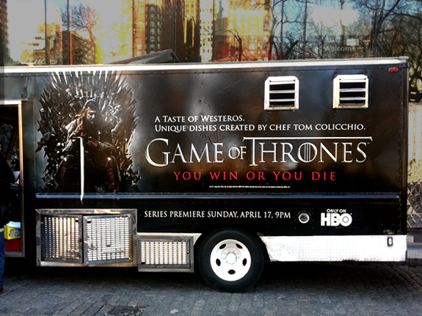
HBO knows that posters alone do not make up a good advertising campaign, so they came up with the idea of Game of Thrones food trucks. Just preceding the season premiere, food trucks were scheduled to be in New York, one week, and L.A. the following week to provide a real taste of Westerosi meals. Tom Colicchio, a well-established TV chef, was the creator of the menu for the food trucks. By having a well-known chef, the food trucks are able to gain credibility in their food because people may be apprehensive of the food served in food trucks. Colicchio included dishes from each of the regions as described in the novels(latimesblog). Some examples include lemon cakes, cooked pigeon, and blackfish stew. Although not everyone will recognize the name Tom Colicchio, by using a chef on the food trucks they are able to establish a kind of credibility to the food. People may not be will to trust a food truck at first, but seeing that a chef created the dishes could make people more trusting of the food truck. These food trucks do a terrific job of reaching out to many different types of people and food can be persuasive. The food trucks allow people who had no interest in the show previously to find a way to connect to it. If a person was previously not interested in the series they may hear about these food trucks and decide to give it a try, and if they like that food it may lead them to check out the show. The food trucks serve right to the people bringing Game of Thrones content in a face-to-face genre. This face-to-face part of the food trucks is part of what makes it so effective. By serving food right out of the series to people it adds a personal touch to advertising. People may be more inpacted by this type of advertisment because they are actively engage in it. Participating in eating the food could leave a more lasting impression than a poster passing by.
Being able to experience something straight out of the series could be appealing because it is uncommon but also because it provides a deeper connection to the characters and setting of the show than most convention forms of advertisement. The food trucks are using the rhetorical appeal of Pathos for its audience. Food is often connected to emotions and memories and the food trucks and trying to use this to make an emotional attachment to the series. By tying the series to something emotional it leaves a more lasting impression. This deeper connection may appeal to some people’s heartstrings which makes them like their favorite characters even more. Another reason this appeal works is because it gives new views some common grounds with those who have been watching the series and the show itself. By providing a connection to the show HBO has the potential of gaining a bigger audience. The food truck works as a way of getting the Game of Thrones brand out there because it incorporates many different medias. It has the written words on the side of the truck, the picture of Ned Stark on the Iron Throne, and the truck has the face-to-face component of the food service. This combination makes the food truck an extremely effective way of advertising Game of Thrones. As the truck drives through the city it may entice people into trying the food on the truck because they would see the pictures and the quote “You win or you die” and that may spark their curiosity and draw them in. Even if people do not sample the food, the pictures and quotes on the side of the truck are constantly advertising the series.
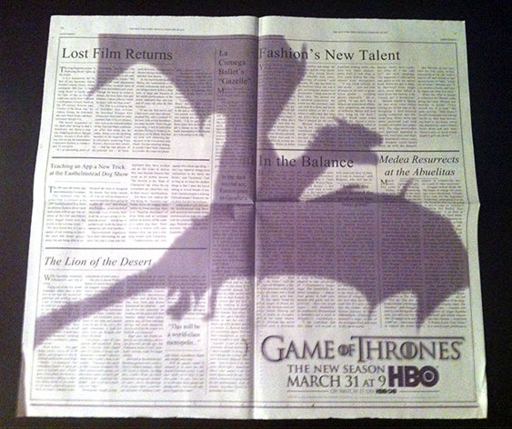
Not everyone likes food trucks and they only went to a few select cities, so Game of Thrones used a newspaper with a well-established reputation, the New York Times. HBO used two pages of the New York Times filled with fake articles concerning the show that had a shadow of a dragon across them. It was printed on the newspaper the day after the Oscars so that anyone looking through the newspaper would come across these pages with the dragon shadow(yahoo). HBO knows that the day after the Oscar there is a high probability that people who are interested in television and movies would be looking at the newspaper, so it was certainly deliberate to put this ad in the day after the Oscars. The audience could be people interested in the Oscars or anyone reading the newspaper. This was a persuasive approach because the series is trying to reach out to those reading the newspaper and convince them to try the show. By using the newspaper Game of Thrones is able to reach a different audience than the food trucks. All kinds of people read the New York Times so it is able to reach people of varying interest. This artifact is in a written mode through a print medium. This type of branding could lead people to believe or become interested in the series because it is in such a reputable newspaper. . This artifact is using the rhetorical appeal of Ethos. It is using ethos because the advertisement is using the reputation of the New York Times to give credibility to the show. People may be more likely to believe that something advertised in a well-known newspaper is interesting. Simply by being in a trustworthy newspaper people are more willing to trust what is said in them. If HBO had put their advertisement in a smaller newspaper there may not have been such an impact on readers, because it might not be trusted like the New York Times.
Game of Thrones has used a variety of strategies to get their brand out into the world; this essay focused on three. The series used posters as a simple way to start and get their name out there, they also took an imaginative idea of using food trucks to promote the series, and then used a reliable and popular newspaper to connect and introduce the show to people. Each of these used different genres to reach the maximum number of people possible in hopes of promoting their product. Part of the success of each of these approaches allowed for the audience to feel or interact with the series. The posters may have attracted people because of the images they portrayed, while the food trucks may have gained recognition because most people like food which gives them a connection to the series in a way most films or tv shows do not provide. The wide appeals of the show and HBO’s tactics of spreading its brand has led Game of Thrones to be such a pop culture icon.

Works Cited
http://www.tor.com/2013/02/27/game-of-thrones-season-3-advertising-hbo/
http://www.adweek.com/adfreak/game-thrones-soars-dragon-ad-new-york-times-147576
https://www.yahoo.com/tv/-game-of-thrones--dragon-ad-flies-across-the-new-york-times-062740428.html
http://latimesblogs.latimes.com/jacketcopy/2011/03/game-of-thrones-food-trucks-heading-to-la-and-ny.html

